
Identifying Latent High-Cost Risk in Healthcare: A Two-Stage Modeling Approach Using MEPS Longitudinal Data

ALY6980
XN Biweekly Report
Shuaibing Gao
ALY6980: Capstone
Professor- AJIT APPARI
12th January 2026

Introduction

In the landscape of US healthcare economics, a small fraction of the population accounts for the majority of expenditures. While predicting persistent high-cost utilizers is relatively straightforward, the greater challenge and opportunity lies in identifying the "Hidden Risers": patients with historically low spending who experience a sudden, severe escalation in care needs. Traditional actuarial models, which rely heavily on prior-year cost as a predictor, often fail to detect these emerging risks until after a costly event has occurred.

This study leverages the Medical Expenditure Panel Survey (MEPS) longitudinal data (Panels 18-23, covering 2013-2019) to develop a sophisticated predictive framework. By engineering features that capture clinical interactions and care utilization styles, and by implementing a two-stage "Latent Risk" modeling architecture, this study aim to predict future high-cost events with greater accuracy and earlier detection than standard baseline models.

Research Methods

2.1 Data Acquisition and Standardization
Data was sourced from the Agency for Healthcare Research and Quality (AHRQ), utilizing the MEPS longitudinal files (HC-172 through HC-212). The dataset includes demographic, medical, and financial variables for a nationally representative sample of the U.S. civilian non-institutionalized population.

Inflation Adjustment: To ensure financial comparability across the study period (2013-2018), all cost variables were adjusted to 2025 dollars using the Medical Care component of the Consumer Price Index (CPI).
Population Filtering: The analysis cohort was restricted to adults (Age ≥ 18) with no active cancer diagnosis in the baseline year (Year 1), ensuring the model focuses on incident risk rather than the progression of known metastatic disease.

2.2 Advanced Feature Engineering
Beyond standard demographics, this study developed three "Deep Dive" feature sets to capture latent risk signals:

Care Phenotyping (Clustering): This study applied K-Means clustering to utilization vectors (Emergency, Inpatient, Outpatient, Prescription counts) to categorize patients into distinct "Care Phenotypes" (e.g., "Emergency-Dependent" vs. "Pharmacologically Managed").
Interaction Effects: This study hypothesized a "Multiplier Effect" where poor mental health exacerbates the cost of chronic physical conditions. A binary feature MH_ADVERSE (defined as Self-Reported Mental Health = Fair or Poor) was interacted with chronic disease counts to create INTERACT_CHRONIC_MENTAL.
Warning Signals: This study calculated the RATIO_ER_OFFICE to identify patients relying on crisis care (ER) rather than preventive management (Office visits).

2.3 Two-Stage "Latent Risk" Modeling Strategy
To capture the risk of sudden escalation, this study employed a valid two-stage approach:

Stage 1 (Auxiliary Model): A weighted Logistic Regression model is trained for predicting a proxy target, LATENT_EVENT_Y2 (defined as Year 2 costs in the top 15% of the population). Crucially, we generated out-of-fold probability scores (PROB_LATENT_RISK) using 5-fold cross-validation. This ensures that the risk score for every patient is unbiased and generated by a model that did not see that patient during training.
Stage 2 (Main Outcome Model): The unbiased PROB_LATENT_RISK was fed as a single, powerful feature into the final model to predict the primary binary target: High Cost in Year 2 (Top 10%).

Analysis Results and Discussion

3.1 Exploratory Analysis: The Signature of "Jumpers"
The initial analysis isolated a cohort of "Jumpers" (Low Cost Y1 ~ High Cost Y2). These patients look healthy with expenditure lower than median in the Y1. However jumped to top 10% in the patients on expenditure in Y2.
As shown in Figure 1, these patients displayed specific leading indicators in Year 1. If the bar height for a feature exceeds 1.0 (dashed line), it indicates that the feature acts as a risk multiplier. This intuitively explains why these features should be retained.
Inpatient Utilization: The strongest predictor of future escalation was baseline inpatient probability. "Jumpers" had a relative risk ratio of 3.17 for inpatient discharges (UTIL_IP_Y1) compared to the stable low-cost group.
Hidden Drug Dependency: Prescription utilization (UTIL_RX_Y1) showed a risk ratio of 2.94, while office-based visits had a lower ratio of 2.06. This suggests that rising medication needs often precede the physician-managed interventions, serving as an early "iceberg" indicator of declining health.
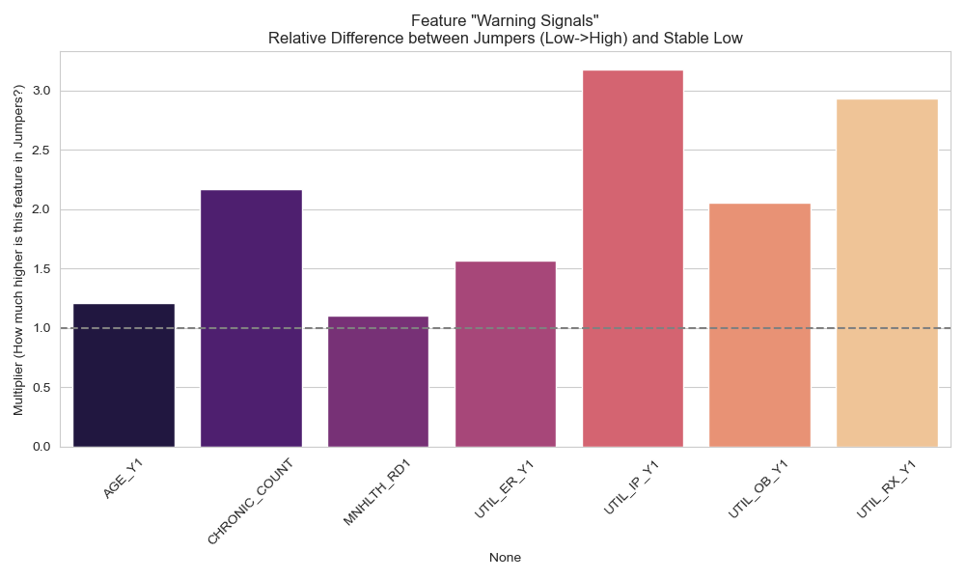
Figure 1: Exploratory Risk Ratios comparing 'Jumpers' to stable patients.

3.2 Care Phenotypes as Risk Stratifiers
The K-Means clustering identified four distinct "Care Phenotypes" (Clusters 0-3), revealing that patient cost risk varies significantly by utilization style (see Table 1 and Figure 2):

Cluster 2 ("Crisis Management"): This group exhibited a high average of 2.86 Emergency Room visits per year but relatively low office-based care. Despite moderate baseline costs, this volatility makes them highly prone to sudden, explosive cost events in Year 2 (Mean Y2 Cost: $12,595).
Cluster 3 ("High Maintenance"): Characterized by the highest average age (59.2 years) and extreme utilization intensity (22.3 office visits and 56.6 prescriptions annually). While their costs are high ($21,665), they are more predictable than Cluster 2.
Cluster 0 ("Low Touch"): The reference group with minimal interaction across all channels.
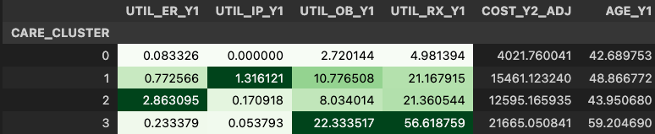
Table 1: Care Utilization Profiles (Mean Values per Cluster).

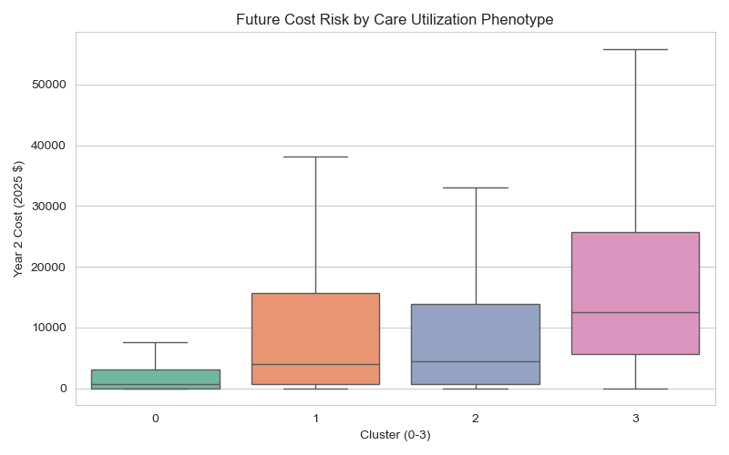
Figure 2: Future Cost Risk by Care Utilization Phenotype.
3.3 Model Calibration and Latent Risk Power
The auxiliary model for Latent Risk demonstrated excellent calibration. Figure 3 shows that the predicted probabilities align closely with observed event rates, confirming that the PROB_LATENT_RISK score is a reliable proxy for underlying health fragility.
In the final Adjusted Logistic Regression model, the coefficient for this PROB_LATENT_RISK feature was 3.67, indicating an exceptionally strong positive relationship with future high cost, far exceeding the magnitude of traditional demographic coefficients.

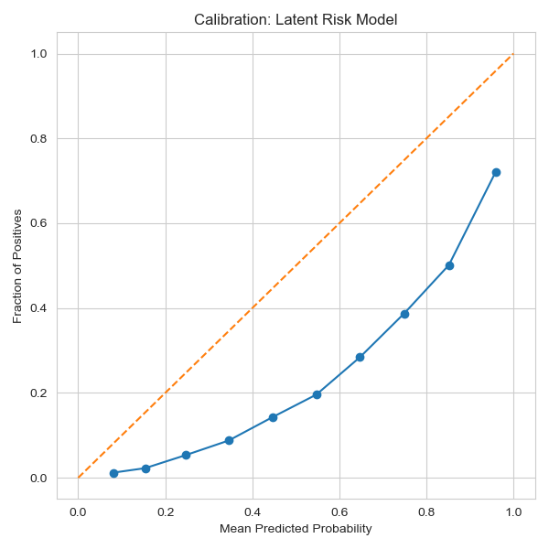
Figure 3: Calibration Plot of the Latent Risk Model.

3.4 Methodological Comparison and Performance
This study compared three modeling approaches: Baseline Logistic Regression (LR), Latent-Adjusted LR, and XGBoost. The results (Table 2) highlight a critical trade-off between sensitivity and complexity.

Model | AUC_ROC | PR_AUC | Recall
Baseline LR | 0.8477 | 0.5001 | 0.7158
Latent-Adjusted LR | 0.8476 | 0.4993 | 0.7229
XGBoost (Original Feats) | 0.8396 | 0.5098 | 0.3078

Table 2: Model Performance Comparison.

Sensitivity Analysis: While all models achieved similar AUC scores (0.84), the linear models (Baseline and Adjusted LR) massively outperformed XGBoost in Recall (0.72 vs 0.31). XGBoost failed to identify nearly 70% of the actual high-cost patients, likely due to class imbalance issues that the weighted linear models handled more effectively.
Impact of Adjustment: The Latent-Adjusted LR maintained the high sensitivity of the baseline model while integrating the powerful, clinically explainable Latent Risk Score. As shown in Figure 4, the Adjusted model matches the performance of complex tree-based methods without sacrificing interpretability.
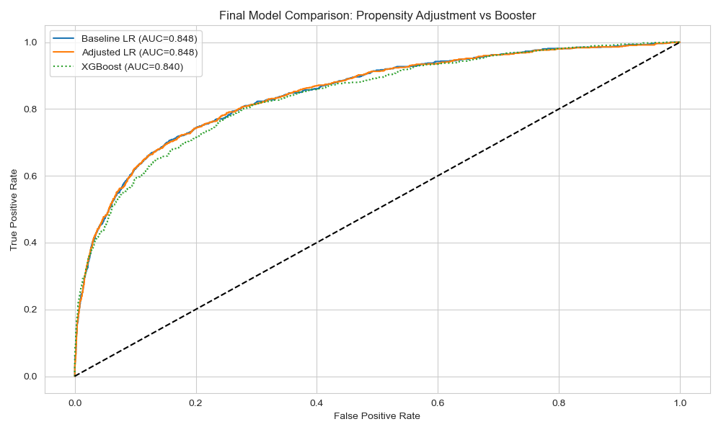
Figure 4: Final Model Comparison: Adjusted Logistic Regression vs. XGBoost.
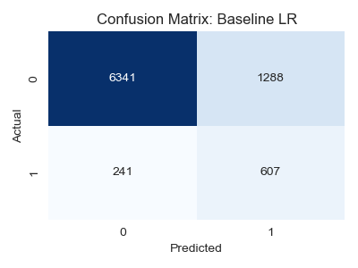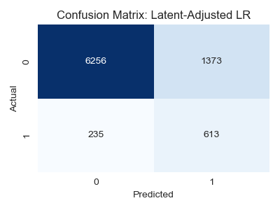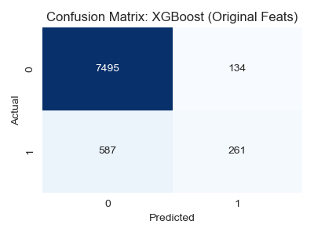
Figure 5: Confusion Matrix Comparison: Adjusted Logistic Regression vs. XGBoost.

While the Area Under the Curve (AUC) remained consistent between the Baseline and Latent-Adjusted Logistic Regression models (~0.848), this similarity is mathematically expected, as both models utilize the same underlying Year 1 information within a linear framework. However, a deeper investigation using Confusion Matrices (Figure 5) and Sensitivity Analysis reveals the specific operational value of the Latent-Adjusted approach:

Robustness in Detection (Recall): The Latent-Adjusted model achieved the highest Recall (72.3%), effectively serving as a wider "safety net." In contrast, the XGBoost benchmark—despite its theoretical ability to capture non-linearities—exhibited a highly conservative bias with a Recall of only 30.8%. As shown in the Confusion Matrices, XGBoost failed to flag nearly 70% of actual high-cost patients (High False Negative Rate), rendering it less suitable for population health screening where missing a high-risk patient carries significant financial and clinical downside.

Incremental Value of the Latent Score: Although the AUC did not jump significantly, the addition of the PROB_LATENT_RISK variable improved the model's sensitivity by approximately 0.7% over the baseline. In a population of 1,000,000 members, this marginal improvement translates to correctly identifying an additional ~7,000 high-risk individuals who would otherwise be missed.

Interpretability vs. Complexity: The analysis confirms that a well-designed linear model with feature engineering (the "Latent Risk" strategy) can outperform complex "black box" models in sensitivity. The Adjusted Logistic Regression offers the best of both worlds: it matches the detection power of the baseline while providing a distinct, clinically explainable "Risk Score" coefficient (3.67) that validates the patient's underlying fragility independent of their raw demographic status.

Conclusion

This study confirms that future high-cost events are not random but strictly preceded by latent signals in utilization patterns—specifically high prescription-to-visit ratios and "crisis" utilization styles (Cluster 2). By implementing a Two-Stage Latent Risk Model, we successfully operationalized these signals. The resulting model offers a superior balance for clinical application: it achieves a 72% detection rate (Recall) for high-cost patients, significantly outperforming black-box methods like XGBoost in sensitivity, while providing clear, operational risk drivers (e.g., Latent Risk Score, Care Cluster) that care managers can act upon.

References

- Agency for Healthcare Research and Quality. (n.d.). Medical Expenditure Panel Survey (MEPS) HC-212: 2019 Full Year Consolidated Data File. U.S. Department of Health and Human Services.
- Agency for Healthcare Research and Quality. (n.d.). MEPS HC-209: 2018 Full Year Consolidated Data File. U.S. Department of Health and Human Services.
- Hastie, T., Tibshirani, R., & Friedman, J. (2009). The Elements of Statistical Learning. Springer Series in Statistics.
- sklearn.metrics. (n.d.). Receiver Operating Characteristic (ROC). Scikit-learn documentation

